**2. Mobile Application Development**

**(Android –Platform)**

**Platform**: Any hardware or software environment in which a program runs, is known as a platform. Since Android has its own runtime environment (JRE) and API, it is called platform.

## What is Android?

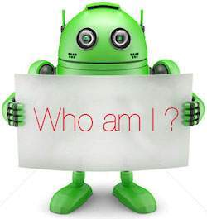

Android is an open source and Linux-based **Operating System** for mobile devices such as smartphones and tablet computers. Android was developed by the **Open Handset Alliance** (**OHA**), led by Google, and other companies(84 firms) include:

[HTC](https://en.wikipedia.org/wiki/HTC),  [Sony](https://en.wikipedia.org/wiki/Sony),  [Dell](https://en.wikipedia.org/wiki/Dell),  [Intel](https://en.wikipedia.org/wiki/Intel),  [Motorola](https://en.wikipedia.org/wiki/Motorola),  [Qualcomm](https://en.wikipedia.org/wiki/Qualcomm),  [Nvidia](https://en.wikipedia.org/wiki/Nvidia), [Texas Instruments](https://en.wikipedia.org/wiki/Texas_Instruments), [Samsung, [T-Mobile](https://en.wikipedia.org/wiki/T-Mobile), Electronics](https://en.wikipedia.org/wiki/Samsung_Electronics), [LG Electronics](https://en.wikipedia.org/wiki/LG_Electronics),  [Sprint Corporation](https://en.wikipedia.org/wiki/Sprint_Corporation),  and [Wind River Systems](https://en.wikipedia.org/wiki/Wind_River_Systems).

The first **beta version** of the Android Software Development Kit (SDK) was released by Google in 2007 where as the first commercial version, Android 1.0, was released in September 2008.

The source code for Android is available under free and open source software licenses. Google publishes most of the code under the **Apache License** (Apache Software Foundation (ASF)) version 2.0 and the rest, Linux kernel changes, under the GNU General Public License version 2.

## Why Android ?

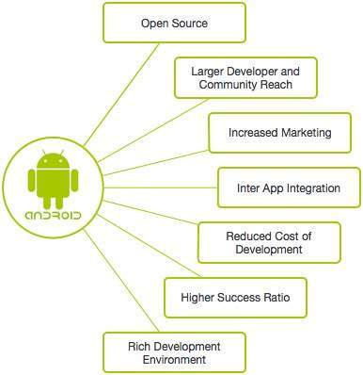

## Features of Android

Android is a powerful operating system competing with Apple 4GS and supports great features. Few of them are listed below –

|  |  |
| --- | --- |
| **Sr.No.** | **Feature & Description** |
| 1 | **Beautiful UI**  Android OS basic screen provides a beautiful and intuitive user interface. |
| 2 | **Connectivity**  GSM/EDGE, IDEN, CDMA, EV-DO, UMTS, Bluetooth, Wi-Fi, LTE, NFC and Wi-MAX.  **GSM:** Global System for Mobile Communications  **EDGE:** Enhanced Data for GSM Evolution  **IDEN:** Integrated Digital Enhanced Network (Motorola variant of TDMA wireless)  **TDMA:** Time Division Multiple Access  **CDMS:** Code Division Multiple Access  **EV-DO:** Evolution Data Optimized/Only  **UMTS**: Universal Mobile Telecommunications System  **Bluetooth:**Bluetooth is a wireless technology standard for exchanging data over short distances from fixed and mobile devices, and building personal area networks.  **Wi-Fi:**Wireless Fidelity (Fidelity: faithful or loyalty)  LTE:**Long-Term Evolution** is a [standard](https://en.wikipedia.org/wiki/Technical_standard) for high-speed [wireless](https://en.wikipedia.org/wiki/Wireless) communication for mobile phones and data terminals, based on the [GSM](https://en.wikipedia.org/wiki/GSM)/[EDGE](https://en.wikipedia.org/wiki/Enhanced_Data_Rates_for_GSM_Evolution) and [UMTS](https://en.wikipedia.org/wiki/Universal_Mobile_Telecommunications_System)/[HSPA](https://en.wikipedia.org/wiki/High_Speed_Packet_Access) technologies.  HSPA: High Speed Packet Access.  **NFC:** Near Field Communication- is a set of short-range wireless technology.  **Wi-MAX:** Worldwide Interoperability for Microwave Access |
| 3 | **Storage**  SQLite, a lightweight relational database, is used for data storage purposes. |
| 4 | **Media support**  H.263, H.264, MPEG-4 SP, AMR, AMR-WB, AAC, HE-AAC, AAC 5.1, MP3, MIDI, OggVorbis, WAV, JPEG, PNG, GIF, and BMP. |
| 5 | **Messaging**  SMS and MMS |
| 6 | **Web browser**  Based on the open-source WebKit layout engine, coupled with Chrome's V8 JavaScript engine supporting HTML5 and CSS3 (Cascading Style Sheets). |
| 7 | **Multi-touch**  Android has native support for multi-touch which was initially made available in handsets such as the HTC (**high-tech computer**) Hero. |
| 8 | **Multi-tasking**  User can jump from one task to another and same time various application can run simultaneously. |
| 9 | **Resizable widgets**  Widgets are resizable, so users can expand them to show more content or shrink them to save space. |
| 10 | **Multi-Language**  Supports single direction and bi-directional text. |
| 11 | **GCM**  Google Cloud Messaging (GCM) is a service that lets developers send short message data to their users on Android devices, without needing a proprietary sync solution. |
| 12 | **Wi-Fi Direct**  A technology that lets apps discover and pair directly, over a high-bandwidth peer-to-peer connection. |
| 13 | **Android Beam**  A popular NFC (Near Field Communication) -based technology that lets users instantly share, just by touching two NFC-enabled phones together. |

## RFIR: Radio Frequency Identification

## NFC is a branch of High-Frequency (HF) RFID

## Android Applications

Android applications are usually developed in the Java language using the Android Software Development Kit.

Once developed, Android applications can be packaged easily and sold out either through a store such as **Google Play**, **SlideME**, **Opera Mobile Store**, **Mobango**, **F-droid** and the **Amazon Appstore**. Every day more than 1 million new Android devices are activated worldwide (more than 190 countries around the world).

## Google Play: Formerly known as the Android Market, is the official app store for Android smartphones and tablets. Google makes software applications, music, movies and books available for purchase and download through the store.

**SlideME**: A Community & Content Marketplace, uniting developers and users, offers products, services and experience that help promote small Android developers and their creative efforts, without locking them into any closed standards.

## Opera Mobile Store : Offers a large number of applications for Android besides other mobile platforms.

**MOBANGO: A** mobile community enabling mobile users to publish, convert and share user generated content with others.

**F**-**Droid**: A software repository (or "app store") for Android applications, similar to the Google Play store.

**Amazon Appstore**: An app store for the Android operating system operated by **Amazon**.com.

## Categories of Android applications

There are many android applications in the market. The top categories are –

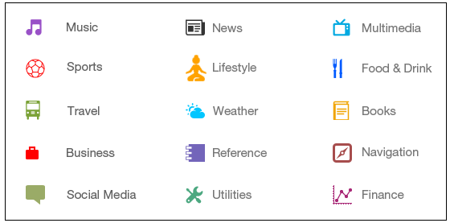

## History of Android

The code names of android ranges from A to O currently, such as Aestro, Blender, Cupcake, Donut, Eclair, Froyo, Gingerbread, Honeycomb, Ice Cream Sandwitch, Jelly Bean, KitKat, Lollipop and Marshmallow. Let's understand the android history in a sequence.

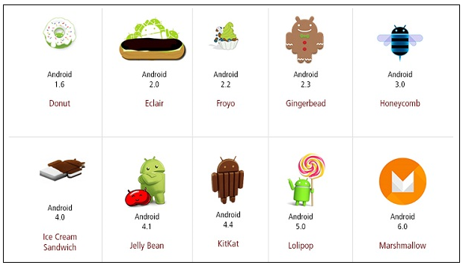

## What is API level?

API (Application Program Interface) Level is an integer value that uniquely identifies the framework API revision offered by a version of the Android platform.

**Android API Levels**

API Levels generally mean that as a programmer, you can communicate with the devices' built in functions and functionality. As the API level increases, functionality adds up (although some of it can get deprecated).

**Android Versions and API Levels**

Each Android version is assigned a unique integer identifier, called the *API Level*. Therefore, each Android version corresponds to a single Android API Level. Because users install apps on older as well as the most recent versions of Android, real-world Android apps must be designed to work with multiple Android API levels.

The **latest version** is **Android** 8 OREO,

|  |  |  |
| --- | --- | --- |
| **Platform Version** | **API Level** | **VERSION_CODE** |
| Android 8.0 | 26-27 | OREO |
| Android 7.0 | 24-25 | NOUGAT |
| Android 6.0 | 23 | MARSHMALLOW |
| Android 5.1 | 22 | LOLLIPOP_MR1 |
| Android 5.0 | 21 | LOLLIPOP |
| Android 4.4W | 20 | KITKAT_WATCH |
| Android 4.4 | 19 | KITKAT |
| Android 4.3 | 18 | JELLY_BEAN_MR2 |
| Android 4.2, 4.2.2 | 17 | JELLY_BEAN_MR1 |
| Android 4.1, 4.1.1 | 16 | JELLY_BEAN |
| Android 4.0.3, 4.0.4 | 15 | ICE_CREAM_SANDWICH_MR1 |
| Android 4.0, 4.0.1, 4.0.2 | 14 | ICE_CREAM_SANDWICH |
| Android 3.2 | 13 | HONEYCOMB_MR2 |
| Android 3.1.x | 12 | HONEYCOMB_MR1 |
| Android 3.0.x | 11 | HONEYCOMB |
| Android 2.3.4  Android 2.3.3 | 10 | GINGERBREAD_MR1 |
| Android 2.3.2  Android 2.3.1  Android 2.3 | 9 | GINGERBREAD |
| Android 2.2.x | 8 | FROYO |
| Android 2.1.x | 7 | ECLAIR_MR1 |
| Android 2.0.1 | 6 | ECLAIR_0_1 |
| Android 2.0 | 5 | ÉCLAIR |
| Android 1.6 | 4 | DONUT |
| Android 1.5 | 3 | CUPCAKE |
| Android 1.1 | 2 | BASE_1_1 |
| Android 1.0 | 1 | BASE |

**Eclipse IDE**

### Eclipse is a free, [Java](http://searchsoa.techtarget.com/definition/Java)-based development platform known for its [plug-ins](http://searchcio-midmarket.techtarget.com/definition/plug-in) that allow developers to develop and test code written in other programming languages (multi-language software development platform). It is used to develop applications in Java and, by means of the various plug-ins, in other languages as well - C/C++, Cobol, Python, Perl, PHP

The Eclipse open source project provides regular releases, currently four releases per year. Every year a larger releases is done, which gets a new release number and a new release name.

As of 2012 the main Eclipse release carried the major version number 4:

| *Table 1. Eclipse releases* | | |
| --- | --- | --- |
| **Release** | **Rename name** | **Release year** |
| 4.2 | Juno | 2012 |
| 4.3 | Kepler | 2013 |
| 4.4 | Luna | 2014 |
| 4.5 | Mars | 2015 |
| 4.6 | Neon | 2016 |
| 4.7 | Oxygen | 2017 |
| 4.8 | Photon | 2018 |

**IDE** stands for Integrated development environment. It's toll for developing Applications. IDE provides features like:

**Syntax Highlighting**

Debugging   
Intellisense   
source code editor etc.

IDEs are designed to maximize programmer productivity and helps the developer to write less number of codes.

**Plug-in**

Plug-in applications are programs that can easily be installed and used as part of our Web [browser](http://searchwindevelopment.techtarget.com/definition/browser). Initially, the Netscape browser allowed us to download, install, and define supplementary programs that played sound or motion video or performed other functions. A plug-in application is recognized automatically by the browser and its function is integrated into the main HTML file that is being presented. Among popular plug-ins to download are Adobe's [Acrobat](http://whatis.techtarget.com/definition/Acrobat), for documentation.

### ****#2. Android 1.5 Cupcake****

Android 1.5 Cupcake was released on 30 April, 2009 Which was totally based on Linux kernel 2.6.27. Android 1.5 was the first release officially use a codename based on a “dessert item” which is known as Cupcake.

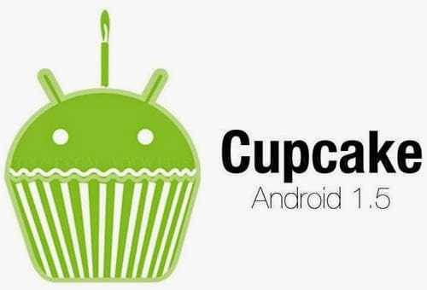

### ****#3. Android 1.6 SDK – Donut****

Android 1.6 Donut was released on Sep 15, 2009 Which was based on Linux kernel 2.6.29.

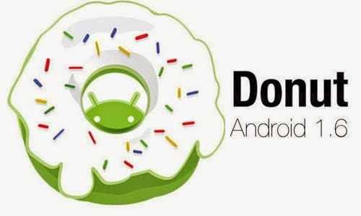

### ****#4. Android 2.0 SDK – codenamed Eclair****

Android 2.0 Codenamed Eclair was released on Oct 26, 2009 Which was based on Linux kernel 2.6.29.

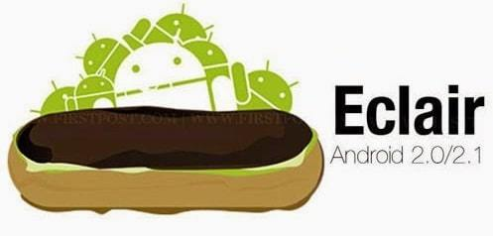

### ****#5. Android 2.2 Froyo****

Android 2.2 Froyo was released on May 20, 2010 Which was based on Linux kernel 2.6.32

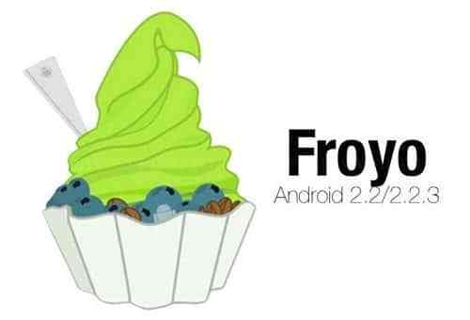

### ****#6. Android 2.3/2.3.7 Gingerbread****

Android 2.3 Gingerbread SDK was released on Dec 6,2010 Which was based on Linux kernel 2.6.35

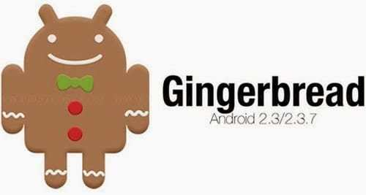

### ****#7. Android 3.0/3.2 Honeycomb****

Android 3.0 Honeycomb was released on Feb 22, 2011 Which was based on Linux kernel 2.6.36. This first device using this version was Motorola Xoom tablet, was lunched on 24 Feb, 2011.



### ****#8. Android 4.0 Ice Cream Sandwich****

Android 4.0 Ice Cream Sanwich was released on Oct 19, 2011 Which was based on Linux kernel 3.0.1. Google’s Gabe Cohen Started this Android 4.0 Version with “theoretically compatible” which production on any Android 2.3.x device.

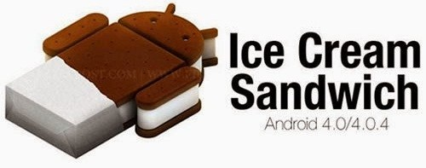

### ****#9. Android 4.1 Jelly Bean****

Android 4.1 Jelly Bean was announce on June 27, 2012 at the Google I/O conference by Google Which was based on Linux kernel 3.0.31. This Android 4.1 Jelly Bean was released to the Android Open Source Project on July 9, 2012. The first Android 4.1 Jelly Bean device is Nexus 7 tablet which was released on July 13, 2012.

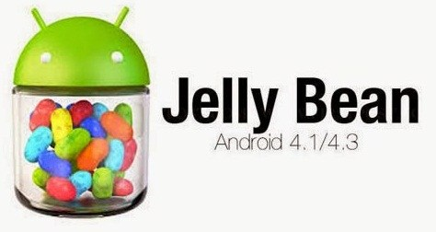

### ****#10. Android 4.4 Kitkat****

Android 4.4 Kitkat was announced on Sep 3, 2013 by Google. This Android 4.4 was optimised to run on a huge range of smartphone then oldest Android Version, Having 512 MB RAM

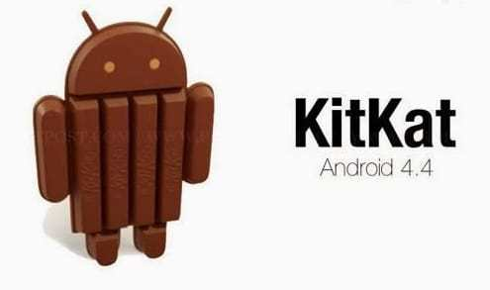

### ****#11. Android 5.0/5.1 Lollipop****

Android 5.0 Lollipop was released on Nov 12, 2014.

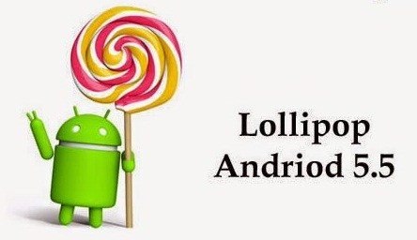

### ****#12. Android 6.0 Marshmallow****

Android 6.0 Marshmallow was released on May 28, 2015 during Google I/O.

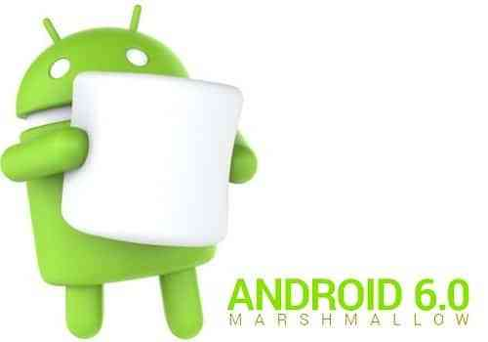

### ****#13. Android 7.0 Nougat****

Android 7.0 Nougat is the latest version of Android which will be release in the month of August or September 2016. If you really Want to know full details of Android Nougat then visit [Wikipedia](https://en.wikipedia.org/wiki/Android_Nougat) to know more about this version.

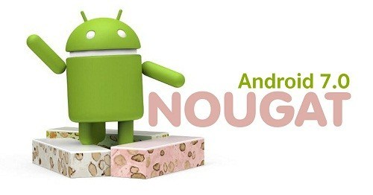

### ****#14. Android 8.0 Oreo****

On 21 August 2017, Google released the name of **Android 8.0**, is **Oreo**.  (Latest Android).

We had already expected the name of **Android O** after watching [**Hiroshi Lockheimer**](https://twitter.com/lockheimer) (Sunder Pichai hand over Hiroshi Lockheimer as head of Android, Chrome OS & Chromecast) twitter profile, I got – he was indicating the name of **Android 8 will be Oreo**. You can see in below figure.

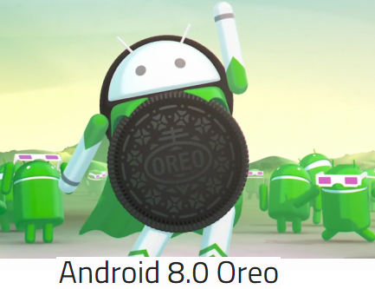

These were 1 to 8 Android version list. Have you noted a interesting point that **all Android version are in alphabetical order.**

N**ame of next Android 9.0**:

**Android 9.0 Popcorn (by Google)**



Android 9.0 Pastry

Android 9.0 Pasta

Android Pastilla

Android 9.0 Puff

Android 9.0 Pandoro

Android 9.0 Panna Cotta

Android 9.0 Parfait

Android 9.0 Popover

Android 9.0 PanCake

Android 9.0 Peanut Brittle

Android 9.0 Pumpkin Pie

Android 9.0 Popsicle

Android 9.0 Pecan Pie

Android 9.0 Poached Pears

Android 9.0 Praline

Android 9.0 Pastille

Android 9.0 Petit Four

Android 9.0 Pinka

Android Piano

Android Pillow

Android Pilot

Android Pudding

Android Pie

Some of the other suggested Android 9.0 version names are -

* Penuche
* Pignolo
* Pizzelle
* Pecan Pie
* Pavlova
* Profiterole
* Pop Tart

### Android P Indian Names

The following popular names have come up from India for naming [Android P version](https://technosamigos.com/tag/Android-P/) -

* Android 9.0 Peda
* Android Pista
* Android Pilu
* Android 9.0 Petha
* Android 9.0 Phirni
* Pav or Pav Bhaji (Indian bread pav)

**2. Android –Platform, Feature, Version etc.**

**Questions**

1. What is Mobile Platform ? Write some examples of good platform. 2
2. What is WAP? Write some features of WAP.3
3. What is Android and why? Write some applications of Android.2-3
4. What’s are Android
5. \levels? Make a list of Android version name sequentially with API levels.4-5
6. Explain Eclipse IDE and Android Development Tools (ADT) Plug-in with their purpose in Android. 4-5
7. What are the possible next Android version names? 1-2
8. Sketch the Block Diagram of Android & IOS Application Development.2
9. Sketch the Block Diagram of Android & IOS Development.2

**Code Meaning**

@dimen refers to **dimension** and it's a file where you define dimensions to use them later from in any layout file.

It's located in res/values/dimens , here's what a sample of the file look like:

<resources>

<!-- Default screen margins, per the Android Design guidelines. -->

<dimen name="activity_horizontal_margin">16dp</dimen>

<dimen name="activity_vertical_margin">16dp</dimen>

</resources>

here activity_veritcal_margin = 16 dp.

and to it's to use it like this:

<LinearLayout

android:id="@+id/activity_main"

android:layout_width="match_parent"

android:layout_height="match_parent"

android:paddingBottom="@dimen/activity_vertical_margin">

here we give this linear layout a bottom padding with 16dp.

@dimen/activity_vertical_margin or whatever @dimen/whatever_key_name is a reference to a dimension that probably is saved in our projectname/src/main/res/value/dimen.xml file

In android we can save several values for example dimensions, strings, integers, drawables.